PORTFOLIO 2026 – Design Layout

Page 1 – Cover

Multi-Brand Marketing
PORTFOLIO 2026
Brand & Marketing Specialist | Social Media Manager | Influencer Marketing

Info : Clean, minimal design
- Elegant typography
- Neutral background with one accent color

Page 2 – Meet Me

Creative Introduction :
Layout ideas:
- Professional photo
- Short introduction

Marketing with a story.
Hello, I’m Afnane — a 360° Marketing Specialist and creative storyteller with a dual Master’s degree in Marketing and Tourism.
I turn business objectives into strategic marketing initiatives, bringing together digital strategy, branding, content, communication, influencer marketing and paid campaigns across B2B and B2C environments.
With experience across hospitality, real estate, retail and lifestyle, I thrive in diverse and international environments, helping brands build visibility, tell their story, connect with their audiences and achieve measurable results.

- Animated statistics
  - 3+ Years of Marketing Experience
  - 12+ Brands Managed
  - 50M+ Sales Influenced
  - 20+Influencers Collaborated With
  - 4+ Industries Worked Across

- Personal values or mission statement - Optional “Only if coherent with design’’
Striving for excellence, leading with integrity, creating lasting impact.

Page 3 – My Journey at a Glance
Sections:
- Education - Check CV
- Professional Experience Timeline
- Skills
- Marketing Tools (displayed with icons, inspired by Helmi's portfolio)
- Languages

Page 4 – What I Do
My 360° approach to marketing
STRATEGY → BRAND → CONTENT → DIGITAL → CONNECTION → IMPACT
Split into six pillars:
- 01 — Strategy: Understanding the business, its objectives, audience and positioning, then building the marketing direction around them.
- 02 — Brand: Shaping how a brand is perceived — from positioning and identity to tone, messaging and overall presence.
- 03 — Content Creation: Turning the brand strategy into stories, concepts and content that people actually want to see, remember and engage with.
- 04 — Digital & Paid: Building visibility through digital channels, paid campaigns and performance-driven initiatives.
- 05 — Influence & Connection: Creating meaningful connections through influencer partnerships, communities, audiences and B2B/B2C communication.
- 06 — Impact: Measuring what matters, learning from performance and continuously improving to move the business toward its goals.
(Add a simple workflow or process diagram.)

Page 5 – Notable Brands

Suites By Le Rêve (★★★★★ Hotel)
Include:
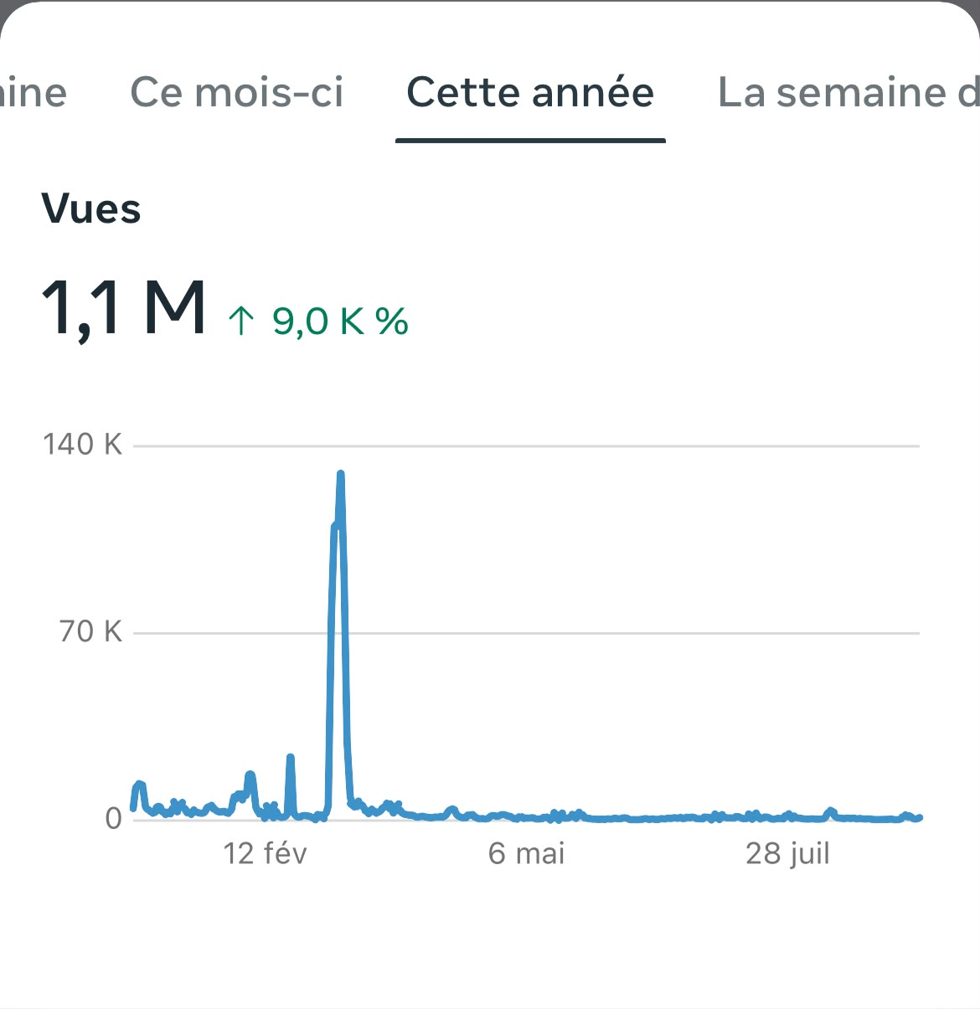
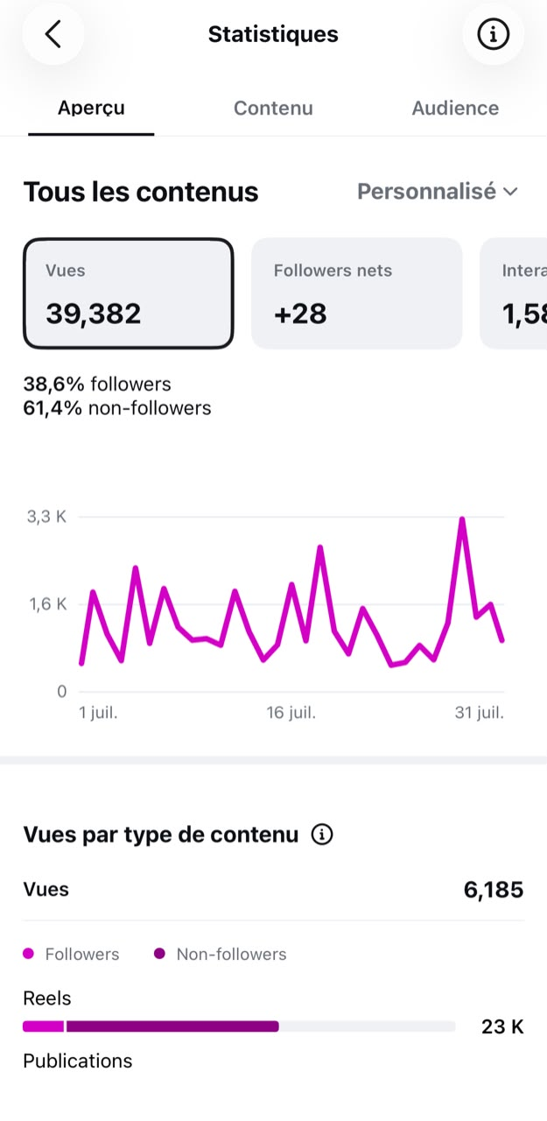
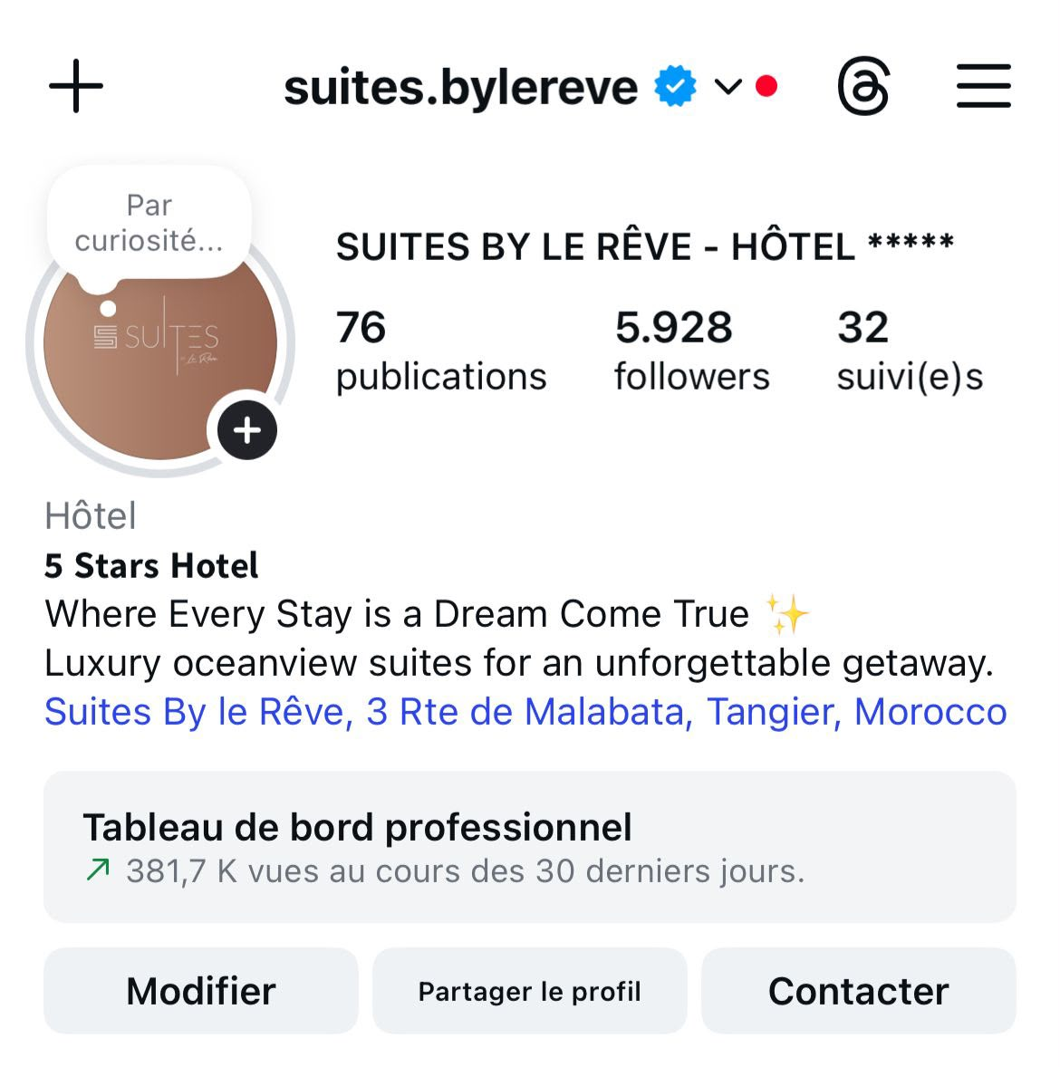
- Brand overview dashboard
For better quality pictures : check link: https://drive.google.com/drive/folders/10qGOMx9hvNuOGaiBmSDVdnSiR2ZTIdjZ?usp=drive_link
- 6 Reels examples:
https://drive.google.com/drive/folders/1bJ--j9wi3BC8iDYI4BtD_pOBqA-nRU1c?usp=drive_link
(Please check Jacqueline Paez Portfolio for reels displaying format.)
https://www.behance.net/gallery/246218979/Social-Media-Manager-Content-Strategy-Portfolio-2026

- Social media posts - offers
https://drive.google.com/drive/folders/1HN0GYdnVXsaLSE6ebBBb6na7hrxlL9z0?usp=drive_link

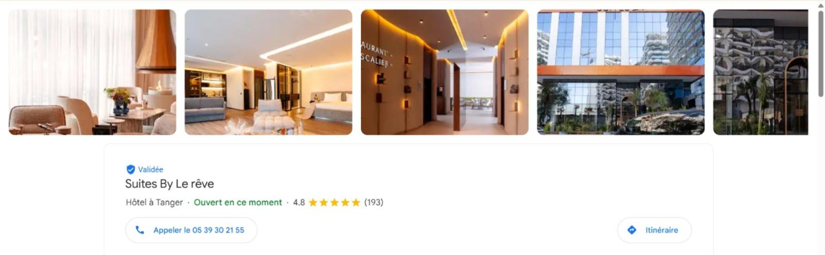
- Performance — Google Business Profile Management & Google Ads Campaigns
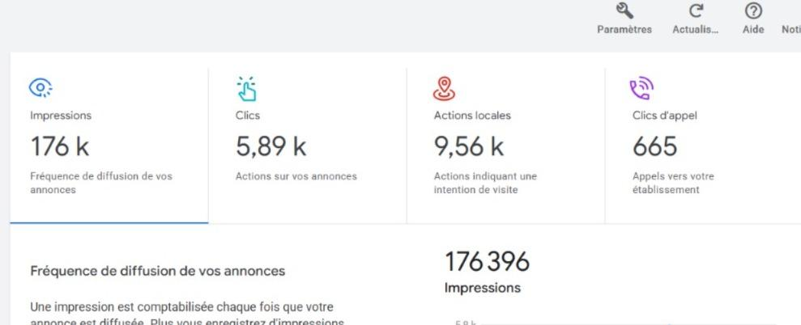
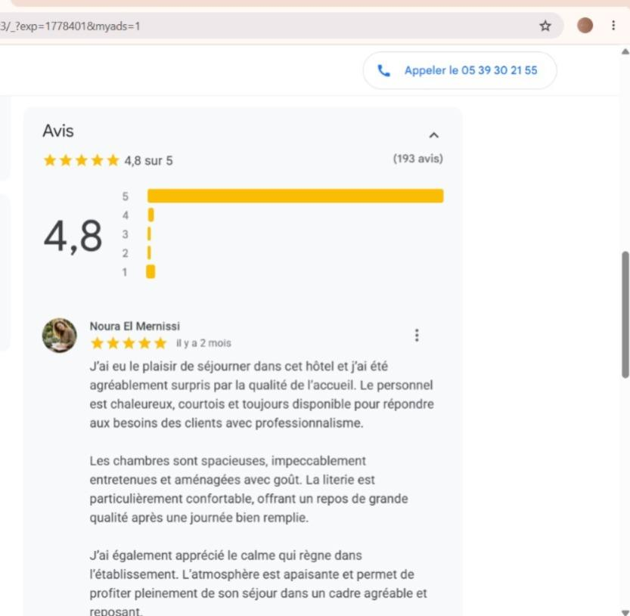

Page 6 – Flamant Rose Appart Hotel
Include:
- Project overview

- 3 Reel examples
- Social Media Posts
https://drive.google.com/drive/folders/1DC_EQaf-TUqEACKml2mK4hjGUjrriIoz?usp=drive_link

Page 7 – Flamant Rose Restaurant
Include:
- Brand identity

- 6 Reel examples
https://drive.google.com/drive/folders/195dbns7zmQ7FaaTCn2i74906ZISvpgsX?usp=drive_link
- Food photography : Selected photos:
https://drive.google.com/drive/folders/1sSR7HJ1Ww-cDMW4c7kA5iZIhscZOAttG?usp=drive_link

Page 8 – Moussa Real Estate (53K+ Followers)
Include:
- Community growth
- Brand strategy
- 6 Reel examples
- 3 Carousel posts
- Project launches
- Campaign performance

Page 9 – Sani-Lux
Include:
- Reel examples
- Product showcases
- Showroom content
- Educational content
- Before & After transformations

Page 10 – Tamazing Morocco
Include:
- Brand Overview and statistics - https://drive.google.com/drive/folders/1vXmp45V6wJO0t0BMSwQgWPSQYVr2Rie6?usp=drive_link

- Fashion campaigns shooting with professional models Behind The Scenes
- 3 Reel examples:
https://drive.google.com/drive/folders/1VMrdAvSUJu3VZno8ggvkZEgbLhhCrTcc?usp=drive_link

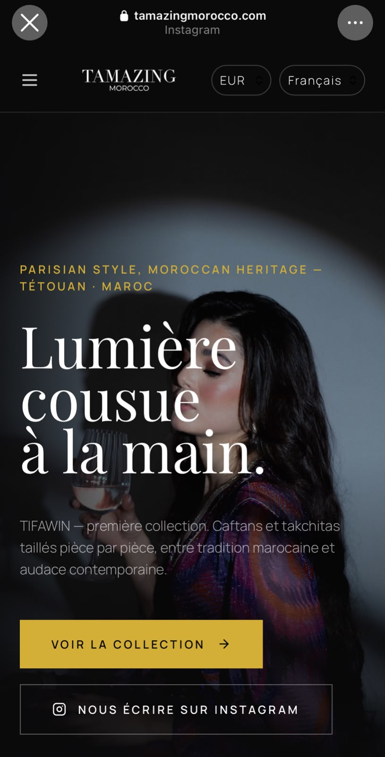
- Product launches - website: www.tamazingmorocco.com

Page 11 – Influencer Marketing & UGC
Featured Collaborations
- Dounia Fox
- Anas Attou
- Anaïs
- Dehran
Include:
- Campaign objectives
- Collaboration outcomes

Page 12 – Storytelling Projects
Featured Creators
- Maddi (M-Arkitectura)
- Zakaria Makkioui
- Sani-Lux (Netflix interviews)
Show:
- Interview concepts
- Creative direction
- Storytelling strategy
- Video production examples

Page 13 – Testimonials & Recommendations
Include:
- Recommendation letters
https://drive.google.com/drive/folders/1m4exkQ5vBvlF2mRKAP6F3exSVef_ECP9?usp=drive_link

- Client feedback and reviews
‘’.....’’

Page 14 – Let's Connect
Contact Information
- Email: amraniafnane33@gmail.com
- Phone: +33 7 59 59 77 86
- LinkedIn:
End with a closing statement, such as:
Thank you for taking the time to explore my work. I look forward to the opportunity to create, collaborate, and make an impact together.

